

Software Engineering
Test Plan Document:
Iteration 0

Philip M. Knouff
Gerald I. Ottman III
Michael D. Bristol
William D. Whelchel II
Randy B. Akers
Radford University
Department of Information Technology
https://php.radford.edu~/softeng12
Date

Revisions

Version | Primary Author(s) | Description of Version | Date Completed
1.0 | William Whelchel | First Draft. Completed document open to be edited. | 00/00/00

Review & Approval
Test Plan Document Approval History
Approving Party | Version Approved | Signature | Date
Dr. T. L. Lewis | 1.0
Customer | 1.0

Iteration Document Review History
Reviewer | Version Reviewed | Signature | Date
Phillip M. Knouff | 1.0
William D. Whelchel II | 1.0
Randy B. Akers | 1.0
Michael D. Bristol II | 1.0
Gerald I. Ottman III | 1.0

Table of Contents
1 Introduction 4
1.1 Iteration Overview 4
1.2 Definitions and Abbreviations 4
1.3 References 4
1.4 Items Not Covered by These Test Cases 5
1.5 Bug Tracking 5
1.6 Quality Control 5
1.7 Adequacy Criterion 5
2 Test Strategy 6
2.1 Testing Process 6
2.2 Technology 6
3 Test Cases 7
4 Customer Acceptance Testing 9

Introduction

Iteration Overview
Iteration 0 will provide the client with the ability to login and logout of the system. The disclaimer indemnifying OpenHack, and its developers will be implemented. The user will be able to see a list of all instances that are candidates for Chaos. The tests will cover searching, logging in, the disclaimer, and selection of a random instance.
We will assume that the user is not attempting to forcibly break the system.

Definitions and Abbreviations
Term | Definition
Test # | Test Case Number / Identifier
Requirement | Requirement that the test cases are validating (number / identifier)
Action | Action to perform or input to produce
Expected Result | Result expected when action is complete
Actual Result | What was actually seen
P / F | Pass / Fail indicator. Checkmark = Pass. “F” = Fail
Notes | Additional notes, error messages, or other information about the test.
OpenHack | The project referred to as a whole
OpenStack | The open-source web framework the system will be designed to operate on
EC2 | The Amazon cloud framework the original ChaosMonkey application ran on
Nova | The OpenStack API the system will interface with
Python | The Language the system will be coded in
C# | The language the original ChaosMonkey application was written in
IDE | Integrated Development Environment

References
Description | Link
Original ChaosMonkey source code | https://github.com/simonmunro/ChaosMonkey
Python documentation | http://python.org/
OpenStack Documentation | http://docs.openstack.org/
VersionOne | versionone.com

Items Not Covered by These Test Cases
Everything in this iteration is being tested.

Bug Tracking
Information on bugs, including, date found, description, status, priority and unique ID, will be tracked in a spreadsheet.

Quality Control
Our test plans will be considered successful if they identify errors in specific components of our system.

Adequacy Criterion
We will use the priority of the user story to develop a scale to track the quality of our test plan.

Test Strategy

Testing Process
All of our user stories are functional requirements and we will write specific test-cases for each one.
Testing will be conducted in a top-down manner, meaning testing will conducted using black-box approach. William Whelchel will be responsible for the unit tests. Randy Akers will be responsible for the integration tests.

Technology
VersionOne
Rackspace cloud servers running OpenStack.

Test Cases

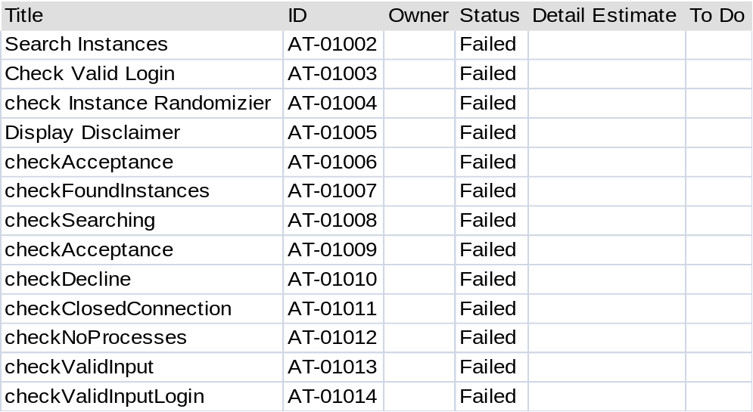

Test # | User Story | Action / Input | Expected Result | Actual Result | P/F | Notes | Date test performed | Tester
1

Customer Acceptance Testing
This section details for each test the steps necessary for the customer to perform acceptance testing and the expected results, and provides a section for recording the observed results. This table should be filled in by the customer as the testing process proceeds. Failed tests should result in bug reports.

Customer Signature: __________________________

Test # | User Story | Action / Input | Expected Result | Actual Result | P/F | Notes | Date test performed

